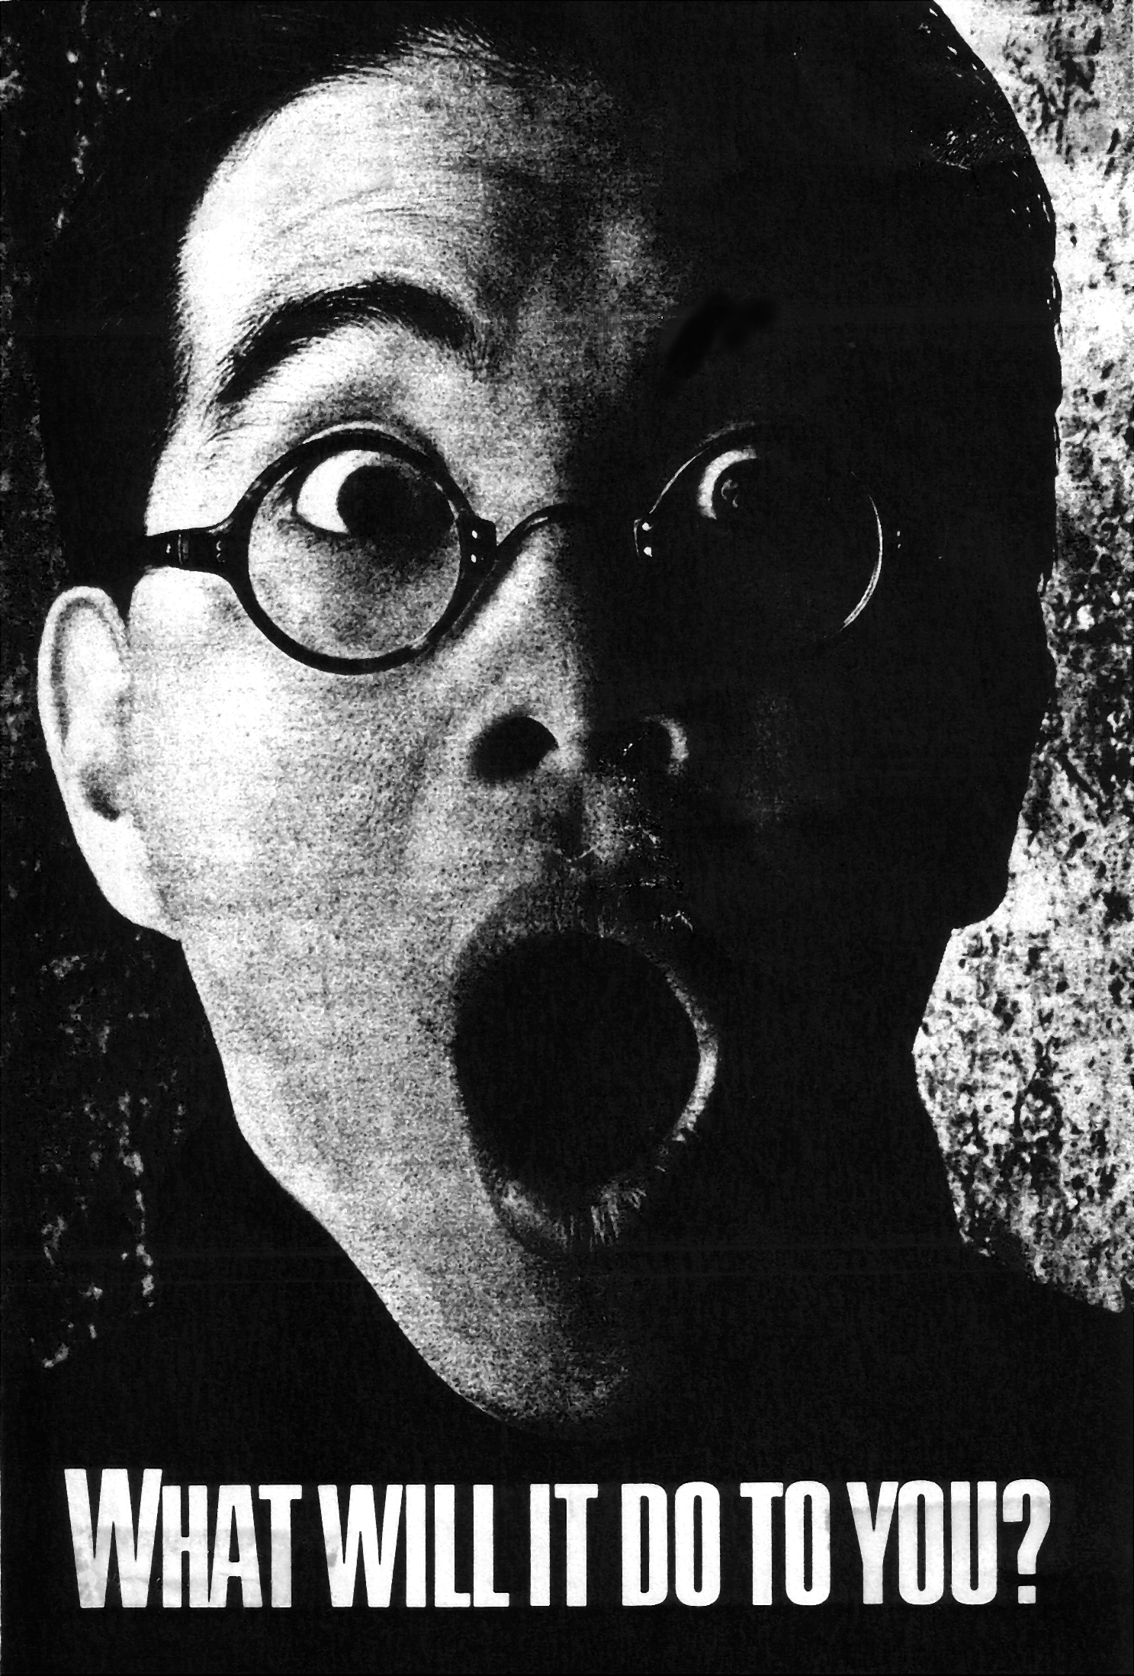

AMERICAN LITERATURE

FINAL
I hope you’ve enjoyed your journey through American Literature. I also hope that this journey does not end when you exit this room. This country is a special place, and special voices have risen from its fertile ground. These stories are our stories, harvested from years of high hopes and dashed dreams. Their characters are cultivated through a vast array of experiences: young people who see the world more clearly than adults, older people who missed their opportunities, different colored people who felt like they never had a chance. Even though you may not have connected with all of them, I hope you can now consider them your own.

As a final opportunity to demonstrate your understanding of the works we’ve covered this term, you will write a literary analysis comparing & contrasting any two (2) of them. Here’s what you’ll need to do…

• Find a news story from the past year or so and identify one of its themes (e.g. man’s inhumanity to fellow man; humans’ heroic struggles against all odds; love & peace prevail; don’t judge a book by its cover; greed & power corrupt; simple is better; we can’t ever truly know a person)

• Pick two (2) literary works from this term that suggest the same theme

• Explore in writing how & why the news story and the two works illustrate this theme (attach a hard copy of the news story to your finished work)

• Identify a conflict from each text (e.g. man vs. man; man vs. society). Then provide a specific example of these conflicts and explain how/why they contribute to the theme you have identified.

• Identify a significant character from each text. Compare & contrast the two in terms of how they are portrayed by the author in order to suggest your theme (Remember the various ways authors can reveal information about characters)

• Identify two (2) more literary elements (e.g. setting, symbolism, irony, POV, style) and examine how they contribute to the theme you selected.

**In all cases, include specific examples/passages from the text!!

Due Date:

100 points

